Andrew Lock: 'Summit 8000' The Tour
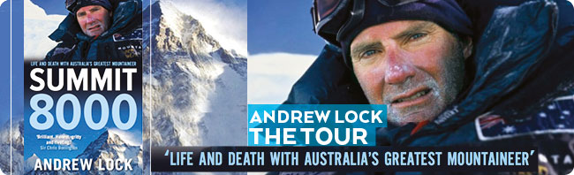
Andrew Lock is the first and only Australian to summit all 14 of the world’s 8000m peaks. To celebrate the release of his thrilling new book SUMMIT 8000, Andrew will share a gripping account of his death-defying ascents in his presentation Summit 8000 The Tour.

“What Andrew has done is outstanding and should not only be seen as an Australian first but more importantly puts him in the running for the international top ten for reaching the toughest grand slam on the planet – the fourteen 8000ers. Peter Hillary, Everest summiteer, author and son of Sir EdmundHillary

Don’t miss your chance to meet Andrew and be inspired by his victories, the near-misses and the great tragedies. This intense human drama infuses his presentations—sometimes funny, sometimes fierce and always fascinating with stories about climbing rivalries and mountaineering politics. The remote and stunning landscapes and cultures which Andrew encounters on his journeys add rich texture to his tale.

Ultimately, you will learn ‘why does he do it?’ Why does anyone take on such a challenge, knowing that they will likely die?

You cannot help but be inspired by the achievements of just one man. Andrew has lived more adventure, hardship, near death and exhilarating life experiences than most people can ever imagine. Hearing his tales of climbing the world’s biggest mountains will rouse your inner adventurer to challenge your own perception of what you are capable of as an individual. Andrew’s presentations have been known to sell out in advance so be sure to grab yourself a ticket while you can – they will not last!

Andrew Lock: 'Summit 8000' The Tour Tickets: $20
Launceston – 25 November. Tramshed Function Centre, 4 Invermay Rd, Launceston
Hobart – 26 November Dechaineux Theatre, UTAS 41 Hunter Street, Hobart,

Presentation starts at 7pm, Book signings from 6:30pm
BUY THE BOOK: Andrew will have copies of his new book SUMMIT 8000 for sale and signing on the night.

'BRILLIANT. Honest, gritty and an incredible...portrayal of the cutting edge high altitude climbing scene of the nineties into the present day.' Sir Chris Bonington, mountaineer

